1. **Personality Assessment (6 marks)**

Take any two-personality test that is based on different personality theories that we have studied. Please digitally cut and paste the results in a word document so that you may reference them later. You may have to do some basic formatting of the results to make them fit. ***Remember, these are simple online personality tests. The results are general and are not to be taken as completely accurate.***

* 1. **Maslow personality test:** [http://similarminds.com/maslow.html (Links to an](http://similarminds.com/maslow.html) [external site.)](http://similarminds.com/maslow.html) results for each level and copy and paste the grey box with the

% of your results under “Maslow Personality” on your results sheet.

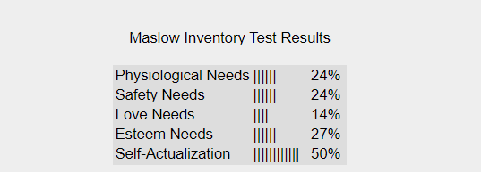

* 1. Cattell’s 16PF questionnaire: [**http://personality-testing.info/tests/16PF.php**](http://personality-testing.info/tests/16PF.php)

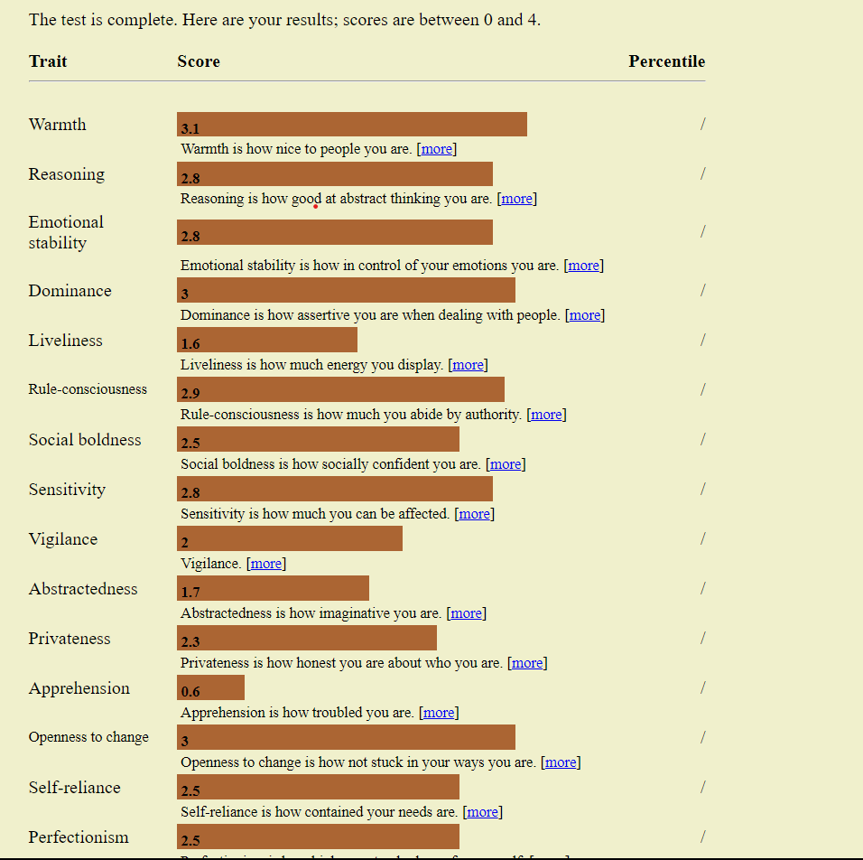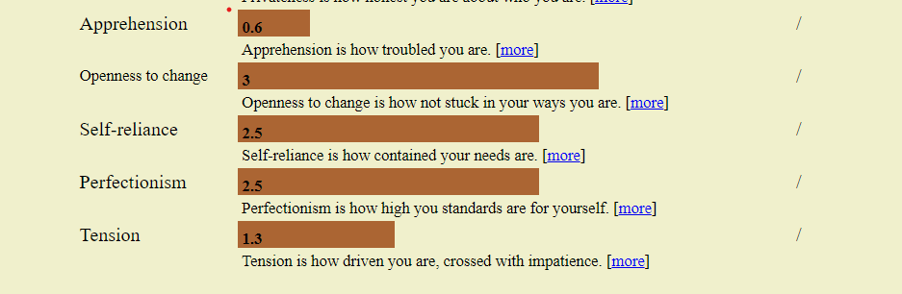

After taking the personality tests, Analyze your results. Discuss the results with at least one other person who knows you (preferably someone who knows you well) and decide if you believe the results accurately describe who you are.

Write a short essay (1.5 - 2 pages) about your experience. Give the name of the test and any relevant information. You may want to include your opinion about the test, the theory being used, whether or not the information is useful or accurate, etc.

**Exploring Self through Psychological Assessments**

Undergoing the Maslow personality test and Cattell’s 16 personality factors tests revealed aspects of my character hitherto unknown to me. The psychological tests used in the examination of my personality were all based on separate theories that aimed at reducing the complexity associated with human behaviors into manageable aspects.  
  
Motivation is a very important fact in a person’s life and many have argued about it. There are several theories in this context, one such was motivated from the theory of Maslow’s hierarchy of needs and was called Maslow’s personality test. The test claimed it would reveal what is most important in my mind at present and hence the hierarchy of needs dictating my actions in life. As a result, I mirrored on the motivators behind decisions, which made it possible for me to reflect regarding my primary needs and desires.  
  
However, after taking up Maslow’s Personality Test, the issues of subjectivity in rating have remained a big challenge for me. Yet, there is what may be considered as an inherent problem with this process of the reduction of a multidimensional human experience into pre-established categories. Despite its success in pointing out several themes as features of my personality, the test was bound to simplify these multiple factors that interact to make life colorful and interestingly complicated.  
  
The exploration became highly multi-dimensional when they moved on to Cattell’s 16 PF Test. As part of Raymond Cattnell’s painstaking factor analysis study, it was aimed at breaking down personality into sixteen different factors for more accurate results. The test was meant not only in broad strokes but also in detail and it covered various aspects of my character including warmth, reasoning, sensitivity, and vigilance and tried to determine my strengths, weaknesses, and unique qualities.

Cattell’s test gave an in-depth investigation into my personality and painted a rich mosaic of these traits. Nevertheless, it emerged that even as complex as the method was, it failed to comprehensively portray the fluid and situation-specific aspects pertaining to personality. Traits are quite transient and they change under the influence of circumstances. Thus, it was difficult to describe their interaction within the context of fixed factors.  
  
My thinking about these tests is that they provide meaningful ways into self-reflection. A Maslow personality test, which concentrates on vital needs, is helpful in comprehending motives that underpin such life decisions. Likewise, with increased depth into different traits in Cattell’s ’s 16 Personality Factors Test, the details are more likely to be observed than by other simple tests.  
  
Nevertheless, one must be careful while using such kind of tools. Although they may make significant contributions, these findings are only pictures and should never be considered comprehensive portrayals. Human personality is a complex phenomenon that results from a wide range of intrinsic and extraneous elements. It is not simple to classify it. We humans, have a tendency to change based on changing circumstances which shape our lives on a daily basis.  
  
Lastly, Maslow Personality Test and Cattell’s 16 Personality Factors test are worthy companions in the journey towards self discovery. The structured frameworks offer a platform for self-reflection thus propelling one to explore parts of themselves that would have remained hidden. However, such assessment must be viewed with certain caution, recognizing that there exists a multi-faceted reality of individuality exceeding the scope of any given test sheet. These tests form only one dimension of the complex textile into which mankind embroiders himself while attempting to understand himself.

1. **Why I Do What I Do (4 marks)**

You will write one short essay (1.5 - 2 pages) in which you apply the principles of a personality theory discussed in class

Freud - id, ego, superego and defense mechanisms Adler - compensation and birth order; Jung - personal unconscious and collective unconscious; Horney - psychoanalytic social theory; skinner learning theory in shaping behavior, Bandura theory of Modelling/ observation, Maslow - hierarchy of needs; Rogers - unconditional positive regard; Big 5 Dimensions of Personality; Eysenck’s Hierarchy of Personality Traits for Psychoticism, extraversion, and neuroticism (P-E-N) to explain something about yourself.

* 1. How you feel in certain situations,
  2. Choices you made or did not make,
  3. How you think in certain situations,
  4. How you acquired certain attitudes or beliefs,
  5. Why you do what you do in certain situations,
  6. Why you feel, think, and do what you do in certain situations.

A good essay will first describe the behavior/emotions in question, and second, discuss why you feel/think/behaved this way from the perspective of a particular personality theorist or theory. The latter (and most important part) will necessitate your identifying the theory you will use, and identifying the concepts you are using as you go.

Emotionally or cognitively complex behavior will probably work best for these papers -- routine behavior (such as getting dressed in the morning) will not lend itself to "analysis."

Essays will be graded based on:

1. How accurately and artfully the psychological principals from the theories are applied.
2. How well-written the essays are: word usage, paragraph and sentence structure, organization, grammar, spelling, all contribute to the paper grade.

**Exploring Personal Responses Through Personality Theories**

Exploring human thinking patterns and behaviors are interesting studies if we examine them with personality theories point of view.    
**1. How I Feel in Certain Situations:**  
At times of uncertainty and stress, my anxiousness and desire to control arise. This is evidenced in Freud’s id, ego, and superego. Id craves instant pleasure, ego struggles for balance, and superego requires conformity with social expectations. These elements have conflicted, and I feel anxious.  
  
**2. Choices I Made or Did Not Make:**  
In reference to my drive for success, Adler’s compensation theory is quite relevant. Having grown up feeling inferior, I have pursued success in all endeavours as a form of retribution and redemption for my alleged deficiencies. In short, feelings of guilt often push people to make choices so that they will feel adequate.  
  
**3. How I Think in Certain Situations:**  
The recurring thought patterns shed light on Jung’s concept of the personal and collective unconscious. In certain circumstances I develop personal archetypal symbols and themes inherent in my own self-consciousness that control my beliefs. This composite picture guides my cognitive responses.

**4. How I Acquired Certain Attitudes or Beliefs:**  
The attitudes and belief come into light as a result of conditioning in his learning theory. This occurred because positive reinforcements by key adults in his earlier year instilled certain values to him. Some of my attitude and beliefs spring from conditioned reaction to environment stimuli.  
  
**5.Why I Do What I Do in Certain Situations:**  
My behavioural choices according to Bandura’s Model of Modelling. In addition, witnessing other people be successful acts as confirmation for some of those behaviors and they become valid choices. Being a vicarious learner, there are certain instances in which I make choices by imitating behaviour associated with positive outcomes.  
  
**6. Why I Feel, Think, and Do What I Do in Certain Situations:**His work enlightens me on why I act the way I do. Self actualization informs my decisions and that I seek social recognition which moulds my emotions, thoughts and behaviors. Together with these needs, they determine how I think in certain situations, which inevitably determines what I do.  
  
The concept of unconditional positive regard developed by Roger will help me understand my interpersonal interaction especially during adolescences’ period. It may be an expression of non-acceptance during the formative years leading to a need for validation and understanding. It impacts my emotional responses as well as those strategies applied for acceptance.  
  
Finally, Eysenck’s P-E-N model provides a synthesis of the personality types I identify. Neurotic anxiety which is a part of a group composed by the factors of extraversion and psychoticism are a part of a group composed by the factors of extraversion and psychoticism, which are themselves factors which give rise to specific behavioural manifestations under socially or difficult circumstances.